EENG 385 - Electronic Devices and Circuits

Lab 1 - Introduction to Multisim and the 555-timer

Lab Handout

# Objective

There are two main objectives of this lab; introduce you to the 555-timer and the Multisim Live tool. The 555-timer circuit you create in this lab will be used in a subsequent lab as part of the BJT curve tracer. You will use the Multisim Live tool throughout the remainder of the term, to test circuit ideas before building them

# Analysis 555 Timer

We will start by examining the behavior of today’s circuit and then use our understanding of circuit to quantify the behavior of the circuit. The circuit shown in Figure 1 is built around the 555-timer, a chip that has been around since the early 1970s. Its used is now limited to niche applications, it is not something you are likely to use much in industry. That said, an analysis of the circuit Figure 1 will allow us to practice valuable skills.

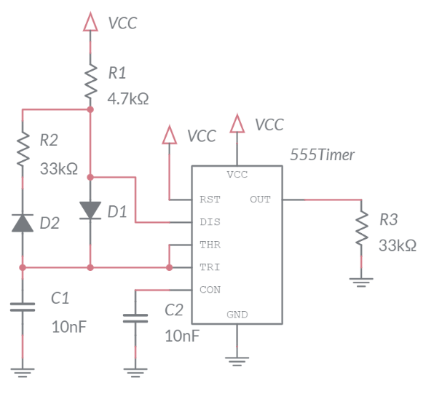

Figure : The output of the 555-timer oscillates with a predictable period and duty cycle.

In order to analyze the circuit in Figure 1, you first need to understand the internal operation of the 555-timer chip. A highly simplified view of its internal structure is shown in Figure 2. You will notice that some of the pins shown in Figure 1 are not shown in Figure 2. These omitted pins do not affect the behavior of the circuit shown in Figure 1, so to simplify the explanation, they are omitted. Finally, note that VCC is the system voltage in Figure 1, for simplicity, we will assume throughout the lab that VCC = 9V.

# 

Figure : A highly simplified rendering of a 555-timer’s internals.

Let’s start our exploration of Figure 2 by examining the pair of green triangles, called comparators. We will call the upper comparator the “R-comparator” because it is connected to the R input of the blue box. Likewise, we will call the lower comparator the “S-comparator”. Notice that each comparator has a + and – input on its left, and its output on the right. The behavior of a comparator is described by the following two statements.

* When the voltage on the + input is larger than the voltage on the – input, the output of the comparator equals VCC.
* When the voltage on the - input is larger than the voltage on the + input, the output of the comparator equals GND.

Use these definitions and the schematic in Figure 2 to answer the following two questions. Assume that VCC = 9V, so state your answers in terms of numerical volts, not symbolically in terms of VCC.

1. For what range of voltages on THR does the R-comparator output VCC?
2. For what range of voltages on TRI does the S-comparator output VCC?

Notice that the THR and TRI inputs to the 555-timer are tied together in Figure 1. We will call this common voltage Vt in the following text – make note of this assignment now.

Next, let’s look at the blue box in the middle of Figure 2, it is an SR-latch. The input voltages to the SR-latch come from the comparator. When the comparator outputs VCC, the SR-latch interprets this as a logic 1. A comparator output of GND is interpreted by the SR-latch as logic 0.

Here is the next state table for the SR-latch.

|  |  |  |  |  |
| --- | --- | --- | --- | --- |
| S | R | Q |  | Name |
| 0 | 0 | Q |  | Hold |
| 0 | 1 | 0 | 1 | Reset |
| 1 | 0 | 1 | 0 | Set |
| 1 | 1 | X | X | Forbidden |

The last element of Figure 2 is the voltage-controlled switch connected to the output of the SR-latch. This switch opens and closes under the control of the signal, hence the arrow head. When the switch is closed, connecting the DIS pin to ground. When the switch is open, leaving the DIS pin “floating”, not connected to any voltage. In reality this voltage-controlled switch is a NPN bipolar junction field effect transistor. However, since we have not studied them, I’ve replaced it with something more intuitive.

1. Now, let’s summarize our understanding of the components in Figure 2 to complete Figure 3. In this figure the vertical axis represents the voltage of Vt (the common voltage of the TRI and THR pins in Figure 1). The voltage range of Vt is split into 3 ranges, 9V-6V, 6V-3V, and 3V-0V. For each of these ranges:
   * describe the logic values on the S and R inputs of the SR-latch (you already did this in a previous question). Write 0 or 1 as the value of S and R,
   * use the S,R logic levels to determine the Q output. Write 0,1 or Q as the value of Q,
   * use the Q output to determine the state of the switch. The value of the Switch should be “open”, “closed” or “hold”. Use “hold” when SR-latch is holding its output.
   * Use the Switch value to determine the state of the DIS signal. The value of the DIS should be “open”, “GND” or “hold”. Use “hold” when the Switch is holding its output.

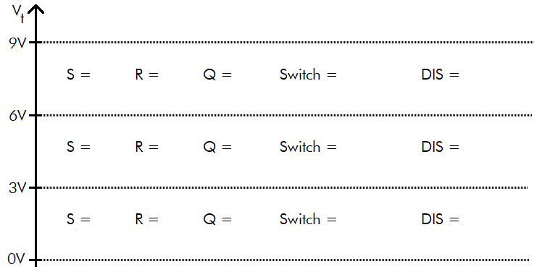

Figure : Determine the effect of Vt on the SR latch. Assume that VCC = 9V.

With our new understanding of the 555-timer, let’s return to the circuit shown in Figure 1 so that we can understand the role of the external components in the operation of the circuit. We will approach this question by replacing the 555-timer with the Vt and DIS signals examined in Figure 3. The resulting circuits, shown in Figure 4 contains resistors, capacitors, a 555-timer and D1, D2, diodes. We will study diodes in much more detail later, but for now, consider them as circuit elements that allow current to flow in one direction, that indicated by the triangle. So, for example, D1 will only allow current to flow downwards and D2 will only allow current to flow upwards.

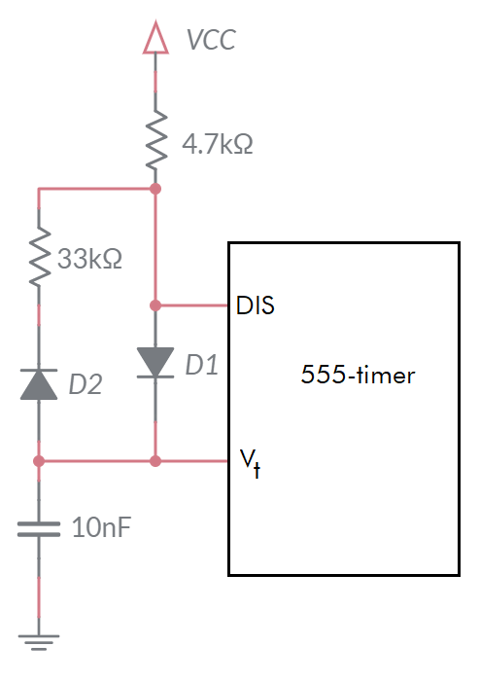

Figure : The circuit in Figure 1with the 555-timer replaced with the 2 signals examined in Figure 3.

Now, you will use the information from Figure 3 to determine to describe what the external circuit in Figure 4 functions like as Vt changes.

1. Determine the circuit behavior in Figure 4 when Vt between 0V-3V by selecting on of the bold-faced items in each sentence or writing the requested equation.

* If Vt is between 0V-3V then DIS is **open/closed** (Q=1).
* If DIS is **open/closed** (copy from previous step) then current wants to flow from VCC through D1 to ground.
* This current flow will **charge/discharge** the capacitor with time constant RC = 47us
* The equation describing the **charge/discharge** capacitor is
* Determine the time required for the capacitor to charge from 3V to 6V.
  + Set the Vt(t) equation equal to 3V and solve for t. This is the time to charge from 0V to 3V. Represent your answer in microseconds and round to the nearest integer.
  + Set the Vt(t) equation equal to 6V and solve for t. This is the time to charge from 0V to 6V. Represent your answer in microseconds and round to the nearest integer.
  + To get the time to charge from 3V to 6V, subtract the time to get to 3V from the time to get to 6V.

1. Determine the circuit behavior in Figure 4 when Vt between 6V-9V by selecting on of the bold-faced items in each sentence or writing the requested equation.

* If Vt is between 6V-9V then DIS is **open/closed**, (Q=0).
* If DIS is **open/closed** (copy from previous step) then charge on the capacitor wants to flow through D2 to the grounded DIS.
* This current flow will **charge/discharge** the capacitor with time constant RC = 330us
* The equation describing the **charge/discharge** capacitor is
* The time required for the capacitor to discharge from 6V to 3V
  + Set the Vt(t) equation equal to 6V and solve for t. This is the time to discharge from 9V to 6V. Represent your answer in microseconds and round to the nearest integer.
  + Set the Vt(t) equation equal to 3V and solve for t. This is the time to discharge from 9V to 3V. Represent your answer in microseconds and round to the nearest integer.
* To get the time to discharge from 6V to 3V, subtract the time to get to 6V from the time to get to 3V.

Let’s now put all the pieces together to see how the external components and the internal structure of the 555-Timer together produce a periodic waveform. To do this we will use Figure 5.

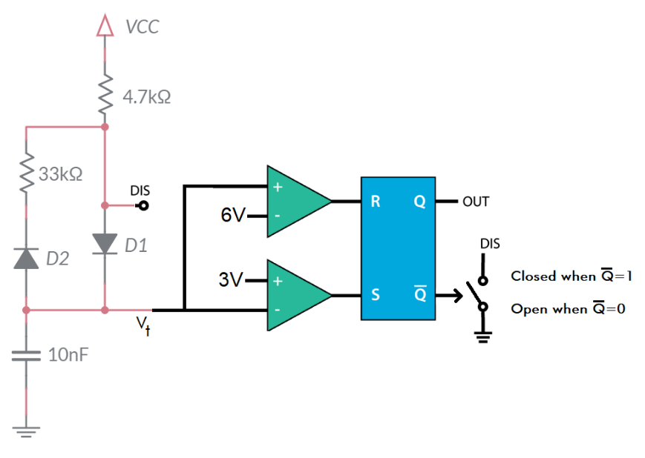

Figure : External circuits and internal organization of the 555-Timer.

You will examine the behavior of this system in terms of Vt. Complete the following set of statements using Figure 5 and the answers you provided to previous questions. When two answers are separated by a “/”, circle the correct answer.

1. Assume that Vt is less than 3v.
   1. Then S = 1 and R = 0
   2. Then Q = 1 and
   3. Then DIS is **open/closed**
   4. Then the capacitor is **charging/discharging**
   5. Then it takes 33us to **charge/discharging** the capacitor from 3V to 6V.

So whenever Vt drops below 3V, the capacitor starts charging, increasing Vt.

1. Assume that Vt is greater than 6V.
   1. Then S = 0 and R = 1
   2. Then Q = 0 and
   3. Then DIS is **open/closed**
   4. Then the capacitor is **charging/discharging**
   5. Then it takes 229us to **charging/discharging** the capacitor from 6V to 3V.

So whenever Vt rises above 6V, the capacitor starts discharging, decreasing Vt.

1. Assume that Vt is between 3V and 6V. I’ll give this one to you.
   1. Then S = 0 and R = 0
   2. Then Q and are unchanged
   3. Then DIS remains unchanged
   4. Then the capacitor charging state remains unchanged
   5. Until Vt goes below 3V or above 6V

So whenever Vt is between 3V and 6V, the capacitor continues doing what it was before Vt entered the range 3V to 6V.

I hope that you can see that Vt continuously oscillates between charging and discharging. As soon as Vt increases above 6V, the SR-latch changes state causing Vt to decrease. As soon as Vt drops below 3V, the SR-latch changes state causing Vt to start increasing. The cycle continues indefinitely.

1. I want you to plot Vt vs. time. To help you, I’ve plotted the voltage vs. time for Vt for the charging and discharging states. You can cut-and-paste the relevant pieces of the curves from Figure 6 to form your answer. Draw as many charge/discharge cycles as will fit.

Figure : Voltage vs. time for Vt in both the charging and discharging configurations.

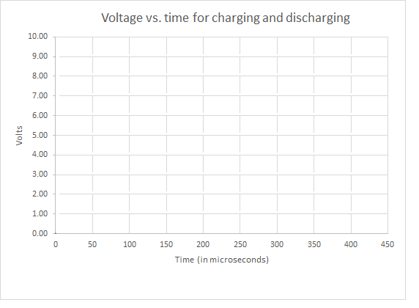

1. Use this information to determine the rise time, fall time and period of the waveform. Note that the rise time corresponds to the output of the 555 timer being high. The fall time corresponds to the output of the 555 timer being 0v.
2. Use the period to determine the frequency of the waveform.
3. The duty cycle of a waveform is the percentage of time that it is at a high voltage level. What is the duty cycle of the OUT pin.

# Simulation 555 Timer

Use the skills you learned in Lab 0 to build the 555-timer circuit that we analyzed in the previous section. Complete the schematic in Figure 7.

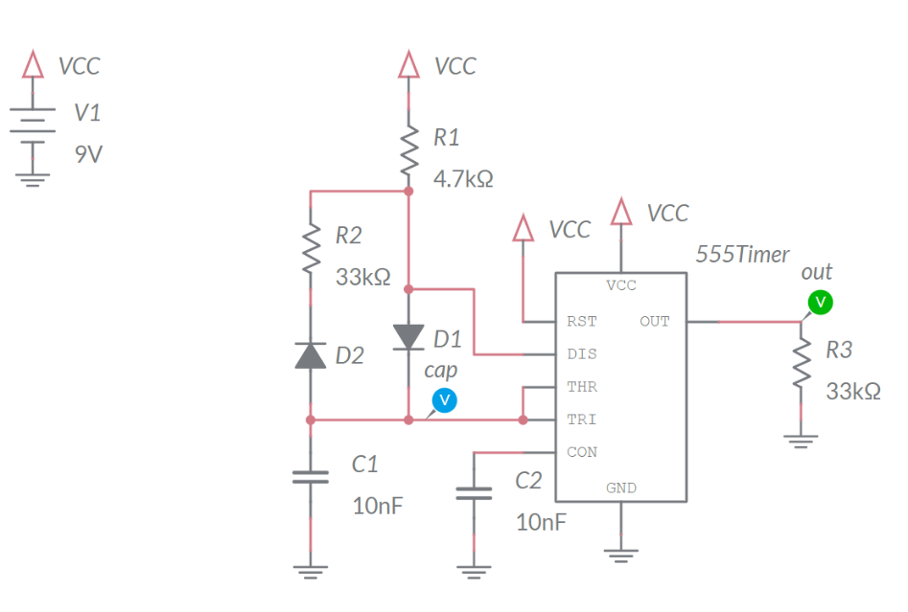

Figure : 555 Timer circuit that you will construct in MultiSim Live.

You will find the components using the information listed in the table below. Make sure to give the resistors and capacitors the correct values and to add the probes to the TRI and OUT pins of the 555 Timer.

|  |  |  |
| --- | --- | --- |
| Component | Tool | Name |
| DC Voltage Supply | Sources | DC Voltage |
| Ground | Schematic connectors | Ground |
| VCC | Schematic connectors | Connector |
| Resistor | Passive | Resistor |
| Capacitor | Passive | Capacitor |
| Diode | Diodes | Diode |
| 555 Timer | Analog | 555 Timer |

# * Make sure to include the probes on the TRI and OUT pins.

# Save your file by clicking on the 3x3 grid of squares in the upper left corner and select “Save”.

1. Export an image of your schematic using the export option in the main menu to output a png file of the schematic.
2. Simulate your schematic for 1ms. Export an image of your timing diagram using the export option in the main menu to output a png file of the schematic. You will notice that the duration of the time low will be significantly different from your analysis. This is because the assumptions you made about the diode in the analysis are not very accurate.
3. Use the timing diagram to measure the Time high, time low, period, frequency and duty cycle of the waveform on the OUT pin. You may find the Cursor function in the Item tab to come in handy. You should find these values very close to those in the analysis.
4. Use the timing diagram to measure the high and low voltages of the TRI pin. You may find the Cursor function in the Item tab to come in handy.

**Assembly 555 Timer**

We will build and test our circuits in parallel with their analysis and modeling. This week, you will solder the POWER INPUT and 555 TIMER subsystems. Before we explore exactly what parts we will be soldering in, let’s get to know our parts better.

The BJT curve tracer kit has many loose thru-hole resistors of different values. It’s worth your time to brush-up on how to interpret the resistors color bands. We will use the handy table in Figure 8 as our guide.

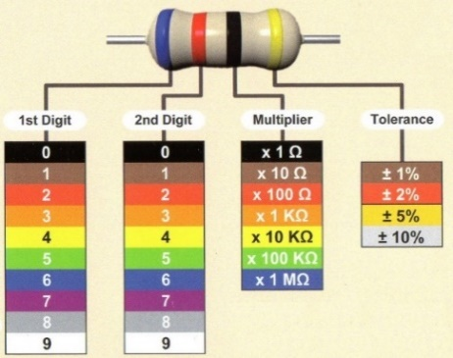

Figure : The colored bands on resistors tell you their resistance.

The resistors provided with your curve tracer kit have 4 colored bands. When looking at a resistor hold it so that the metallic gold band is to the right – all our resistors are 5% tolerance. With the resistor correctly positioned, read the color bands from left to right, converting the colors into the numerical codes given in Figure 8. For example, let’s say that from left to right the color bands are red, red, orange, gold. This converts to 22x1kΩ ±5% The first three bands are the resistance, in this case 22kΩ. The fourth band is the range of resistances you can expect the resistor to have. This means that the actual resistance of our example resistor could be as low as 22kΩ – 0.05*22kΩ = 22kΩ – 1.1kΩ = 20.9kΩ or as high as 23.1kΩ. To make sure that you are ready for the lab, complete the blank space in Table 1with the color or resistance code.

Table : Complete the missing entries in the table of resistance color codes.

|  |  |  |  |  |
| --- | --- | --- | --- | --- |
| Value | Band 1 | Band 2 | Band 3 | Band 4 |
|  | Red | Red | Brown | Gold |
|  | Red | Red | Red | Gold |
| 3.3k | Orange | Orange |  | Gold |
| 4.7k |  |  | Red | Gold |
|  | Blue | Grey | Red | Gold |
| 10k | Brown |  |  | Gold |
| 15k |  |  | Orange | Gold |
| 33k |  | Orange |  | Gold |
|  | Yellow | Purple | Orange | Gold |
| 100k |  | Black |  | Gold |
|  | Yellow | Purple | Yellow | Gold |

# This week, you will be soldering in the components associated with the POWER INPUT, 555 TIMER subsystems. These subsystems are names in Figure 9. It is important that you do not solder in any of the other components in any of the other subsystems.

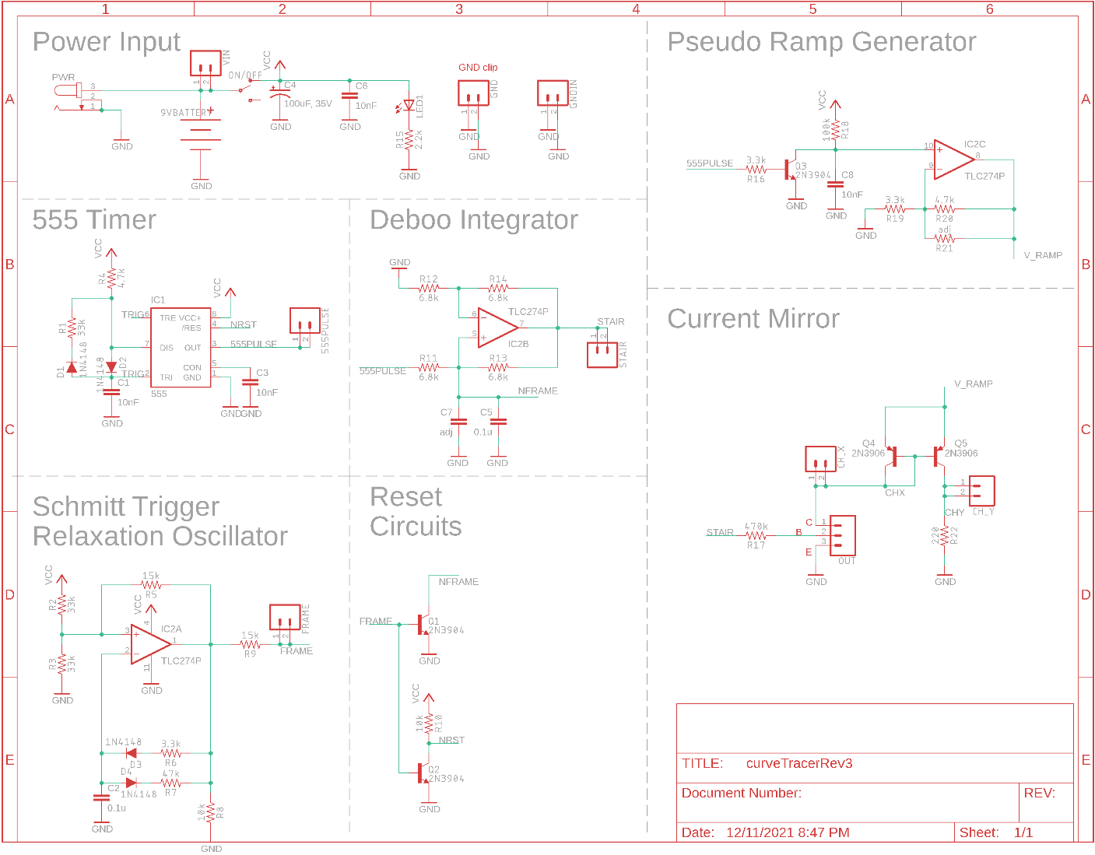

Figure : The schematic for the BJT curve tracer.

**POWER INPUT Subsystem**

Take a look at the POWER INPUT area of the schematic in Figure 9. This subsystem allows you to supply power to the BJT curve tracer board from either a AC/DC converter or through a pair of test points VIN and GND. A SPDT slide switch allows the user to turn the BJT curve tracer on or off while leaving the power input connected. An indicator LED confirms the BJT curve tracer is powered on when it is illuminated. A pair of capacitors smooths out the power delivered to the BJT curve tracer.

**555 TIMER subsystem**

The 555 TIMER subsystem in Figure 9 is identical to the circuit that you analyzed in in Figure 4.

Most of the parts in this schematic have a designator and a value. The designator is a letter followed by a number. The designator letter tells you what type of part it is, “R” for resistor, “C” for capacitor, etc. The designator number tells you the index of that part in the entire collection of that part type. For example, the voltage divider in the relaxation oscillator consists of resistor s R2 and R3, both 33kΩ.

The schematic in Figure 9 is the starting point for the layout shown in Figure 10. The physical position of the parts in the schematic and layout are unrelated, the schematic is an abstraction of the finished layout. The layout contains all the data used in the fabrication of the PCBs – the layout and the fabricated PCB are identical. Take a moment to look at the layout and compare it to the PCB for the curve tracer paying attention to the following bullet points.

* The green circles in Figure 10 are the layout are plated through holes in the PCB
* The red lines in Figure 10 are traces (wires) on the top side of the PCB
* The blue lines in Figure 10 are traces (wires) on the bottom side of the PCB
* The grey lines and text in Figure 10 are white silk screen on the PCB

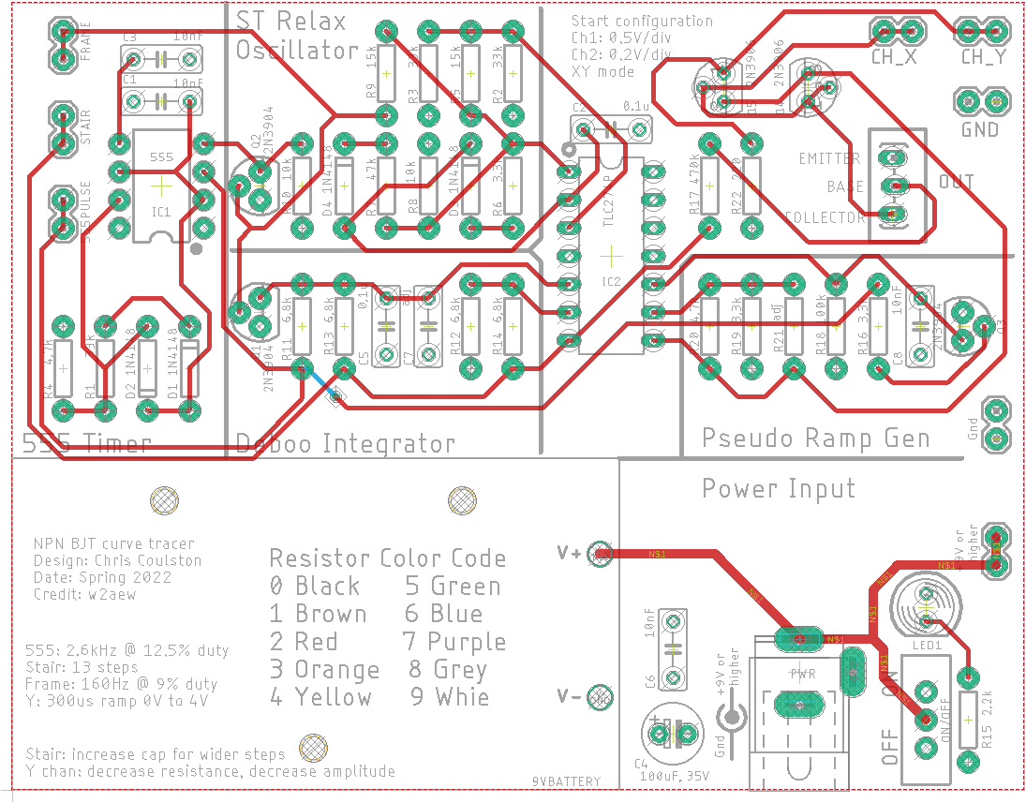

Figure : The layout of the BJT curve tracer.

The parts designators are important because they are the same in the schematic and the layout, providing you with a means to find a part. You should take a moment to notice that parts logically related in the schematic are physically proximal in the layout.

Table : List of parts to be soldered into the PCB this week. Shaded cells are polarized components, watch their orientation.

|  |  |
| --- | --- |
| POWER INPUT | 555 TIMER |
| PWR JACK | R4/4.7k |
| ON/OFF | R1/33k |
| C4/100uF | D1/1N4148 |
| C6/10nF | D2/1N4148 |
| LED1 | C1/10nF |
| R15/2.2k | C3/10nF |
|  | IC1/555 |

# Polarized parts

Most of the parts that you will solder into the PCB can be installed in more than one way. Parts which must be installed in a correct orientation are called polarized. Polarized parts have some physical indication of their orientation and the silk screen will have some marking to show you where this physical indicator should be aligned. Let’s walk through all the polarized parts and how you will install them in the PCB.

* 555-Timer

The chip has a small round indentation in the corner which indicates pin 1. This indentation should align with the white circle on the PCB silk screen.

* Diodes

The diodes are orange with a black stripe on one end. This black strip needs to align with the white stripe on the PCB silk screen. Caution, the diodes do not have a consistent orientation – pay close attention when stuffing parts into the PCB.

* Red 100uF capacitors

The 100uF capacitors have a white stripe which indicates the negative terminal. The negative terminal should align with the white bar (opposite the “+” bar) on the PCB silk screen.

* Green LED

The green LED has a flat side which indicate the negative terminal. This flat side should align with the flat side of the PCB silk screen.

# Test Points

Test points make electrical connections to important points in the circuit and frequently are the target of test and measurement equipment. All the test points on the BJT curve tracer are pairs of pads that you will connect with a single piece of wire formed into a loop about 1cm high. I have found the best source for the wire used to make these loops to be the cut off ends of resistor leads. You will need to make a 8 test point connections to the following terminals – they are labeled in white silk screen scattered around the PCB.

* CH_X
* CH_Y
* GND (adjacent to CH_X and CH_Y)
* 555PULSE
* STAIR
* FRAME
* +9V or higher
* Gnd (adjacent to +9V)

# Part Identification

# To make sure that you can positively identify all the elements in the schematic complete Table 3 by filling in the Match column with the letter that corresponds to the Schematic Symbol in for that Physical Part.

Table : Match the schematic symbol with the corresponding part.

|  |  |  |  |
| --- | --- | --- | --- |
| Schematic Symbol |  | Match | Physical Part |
| A |  |  | WCAP-ATG8 |
| B |  |  | 151051VS04000 |
| C |  |  | Goldmax 32 Series |
| D |  |  | PJ-202A |
| E |  | I | TC254P |
| F |  |  |  |
| G |  |  | EG1218 |
| H |  |  | DO-35 |
| I |  |  | CF 4-7k |

# Assembly and Testing

You should take care and align the resistors so their gold tolerance bands all face the bottom of the board. This will make it easier to read their values and compare your work to pictures of the assembled board. This will be part of the grading rubric. Look at Appendix A for recommendation on how to solder through hole parts.

**Assemble POWER INPUT Subsystem**

You should start your soldering with the POWER INPUT subsystem. This will include the following parts:

* 100uF capacitor – POLARIZED!
* Green LED – POLARIZED!
* 10nF capacitor
* Power jack
* ON/OFF slide switch
* 2.2k resistor
* +9V or higher test point
* Gnd test point

After you solder in all the components, you should test and correct any problems before soldering any other components.

**Test POWER INPUT Subsystem**

1. Check the resistance between the “+9V or higher” and “Gnd” test points with the ON/OFF switch in the OFF position. You should get an overload condition on the DMM – there is essentially infinite resistance with the switch in the OFF position.
2. Check the resistance between the “+9V or higher” and “Gnd” test points with the ON/OFF switch in the ON position. You should get an overload or you may see the DMM resistance values jumping around – you should not get 0Ω.
3. Power up the BJT curve tracer:
   * Put the ON/OFF switch in the OFF position,
   * Apply power to the board either through your AC/DC converter or using the lab power supply. If you are using the lab power supply, set the voltage to 9V and the current to 100mA,
   * Throw the ON/OFF switch to the ON position,
   * The green LED should illuminate.
     + If you are using an AC/DC converter to supply power, check the voltage at the “+9V or higher” and “Gnd” test points with a DMM. You should expect a volt or two higher than the AC/DC rated output voltage – they run high under low load conditions.
     + If you are using the lab power supply to provide power, the current should be less than 20mA.

**Debugging POWER INPUT Subsystem**

It’s pretty hard to do anything drastically wrong when assembling the POWER INPUT subsystem. I would expect most of the problems to be failures in your test procedure rather than failures of the board. If your BJT curve tracer board fails one of the test steps in the previous section, I’ll provide some guidance on what may have happened and how you can correct it.

1. If you are getting low resistance with the ON/OFF switch in the off position:
   * Make sure the ON/OFF switch is in the OFF position,
   * Check that you do not have a solder bridge on the rear of your PCB,
   * Make sure you are reading the DMM correctly. The reading when the ON/OFF switch in the off position should be the same as when you hold the probes apart in air.
2. If you are getting a different resistance with the ON/OFF switch in the on position:
   * Make sure the ON/OFF switch is in the ON position,
   * Make sure you are reading the DMM correctly. The reading when the ON/OFF switch in the on position should be the same as when you hold the probes across a spare 2.2k resistor.
   * Check the orientation of the green LED, you may have installed it in backwards.
3. If the green LED does not illuminate when power is applied ad the ON/OFF switch is in the on position:
   * Test that you are applying power. Put a DMM in voltage mode and check the +9V and Gnd test points.
   * Check the orientation of the green LED, you may have installed it in backwards.
   * Check the solder joints on the 2.2k resistor and the green LED. When you attempt to wiggle either of these two components, they should not move at all.

**Assemble 555 TIMER Subsystem**

You should start your soldering with the POWER INPUT subsystem. This will include the following parts:

* 555 timer IC – POLARIZED!
* 1N4148 diodes – POLARIZED!
* 10nF capacitors
* 4.7k and 33k resistors
* 555PULSE test point

After you solder in all the components, you should test and correct any problems.

**Test 555 TIMER Subsystem**

1. Power up the BJT curve tracer:
   * Put the ON/OFF switch in the off position,
   * Apply power to the board either through your AC/DC converter or using the lab power supply. If you are using the lab power supply, set the voltage to 9V and the current to 100mA,
   * Throw the ON/OFF switch to the ON position,
   * The green LED should illuminate.
     + If you are using an AC/DC converter to supply power, check the voltage at the “+9V or higher” and “Gnd” test points with a DMM. You should expect at a volt higher than the AC/DC rated output voltage – they run high under low load conditions.
     + If you are using the lab power supply to provide power, the current should be less than 50mA.
2. Power up an oscilloscope, attach a probe to Channel 1 and configure it as follows:

|  |  |
| --- | --- |
| Ch1 probe | OUT pin of 555 Timer |
| Ch1 ground clip | BJT ground loop |
| Horizontal (scale) | 50us |
| Ch1 (scale) | 1V or 2V (whatever fits better) |
| Ch2 probe | TRI pin of 555 Timer |
| Ch2 (scale) | 2V |
| Trigger mode | Auto |
| Trigger source | Ch1 |
| Trigger slope | ↑ |
| Trigger level | 4.5V |

Set the GND reference of Ch1 and Ch2 to the lowest visible reticule – the waveforms will overlap the same that they did in the MultiSim simulation. The OUT pin of the 555 Timer is sent to the 555PULSE header pins. The TRI pin of the 555 Timer is available by attaching an oscilloscope probe to any of the red circled leads shown in Figure 11.

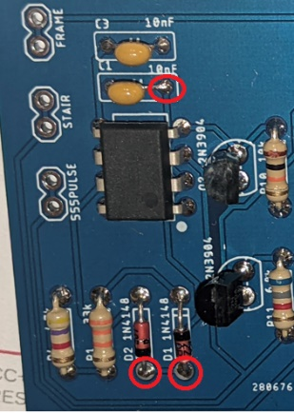

Figure : The TRI pin of the 555 Timer is available at any of the red circled leads.

1. Screen shot the two waveforms and include in your lab report.

**Debugging 555 TIMER Subsystem**

Compare to the POWER INPUT subsystem, there are many more ways to foul up the 555 TIMER subsystem. If your BJT curve tracer board fails one of the test steps in the previous section, I’ll provide some guidance on what may have happened and how you can correct it.

1. If your green LED is no longer illuminating when you apply power to the BJT curve tracer:
   * Verify that you are applying power to the BJT Curve Tracer by probing the +9V and Gnd test points with a DMM in voltage mode and with the ON/OFF switch in the ON position.
   * Verify that the ON/OFF switch is in the ON position.
   * Check the orientation of the 555 timer IC.
2. Your 555 timer is not generating a proper waveform
   * Make sure that 555 TIMER parts are inserted in the correct location.
   * Check the orientation of all the 555 TIMER parts

# 

Figure : The completed BJT Curve Tracer under test.

# Turn in:

Make a record of your response to numbered items below and turn them in a single copy as your team’s solution on Canvas using the instructions posted there. Include the names of both team members at the top of your solutions. Use complete English sentences to introduce what each of the following listed items (below) is and how it was derived.

**Analysis:** Question 1, 2 Voltage to assert S and R

**Analysis:** Question 3 SR Latch truth table

**Analysis:** Question 4 Vt vs. TRI state

**Analysis:** Question 5 Time to charge 3V to 6V

**Analysis:** Question 6 Time to discharge 6V to 3V

**Analysis:** Question 7 Behavior when Vt is less than 3V

**Analysis:** Question 8 Behavior when Vt is greater than 6V

**Analysis:** Question 10 Plot Vt vs. time

**Simulation** Question 1 Schematic output from simulation

Question 2 Grapher output from simulation

Question 3 OUT waveform characteristics

Question 4 TRI waveform characteristics

**Assembly**  Table 1 Resistance color code

Table 3 Parts Identification

Screen capture of 555 timer output

**Analysis**

Complete the columns of the following table using the information you found throughout this lab. Represent your answer to 3 significant figures using the units given in the quantity column. You will be completing this table in lab 2, so make sure to save your answers.

|  |  |  |  |
| --- | --- | --- | --- |
| Quantity | Analysis | Simulation | Assembly |
| Time high (us) |  |  |  |
| Time low (us) | 239us |  |  |
| Period (us) |  |  |  |
| Frequency (kHz) |  |  |  |
| Duty Cycle |  |  |  |

# Appendix A: Soldering

* **Get organized:** I always like to have a hardcopy of the schematic and layout before I start assembling a PCB. This helps me locate part designators, keep track of my components, and ensure that I am putting the right part in the right place. You can find these ancillary files posted on Canvas.

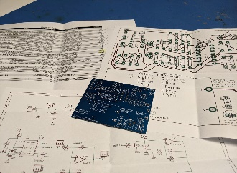

* **Select a part to install:** I would highly advise soldering in the lowest profile part first. By profile, I mean the height of the part off the board. In our case, this will be the resistors. I always install all the resistors of the same value at the same time. In the picture below, this is the 8.6k resistors. I use a pair of cutters to remove the resistors from the paper tape.

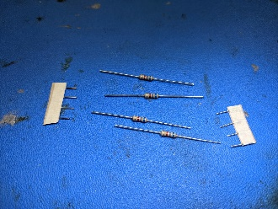

* **Form leads:** The metal wires extending out of a part is a lead. You will have to modify the shape of these leads to make installing the part in the board easier. Use a pair of needle noise pliers for this task. Bend the resistors as close to the resistor’s body as possible.

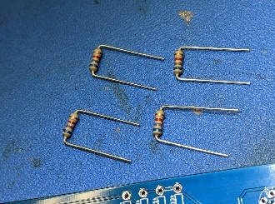 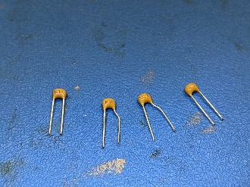

* **Stuff components:** This sounds easy, but stuffing the board is the most important step because you are going to double check that you are installing the correct component in the correct place! This means reading the color codes on the resistor and checking that it matches the parts value silk screened on the PCB (you may want a copy of Table 1 on hand). Also, you should always align resistors so that their tolerance bands are on the same side - because you take pride in your work. Once inserted, flip the board over and bend the leads outward so that the resistor does not slip out of its hole during soldering.

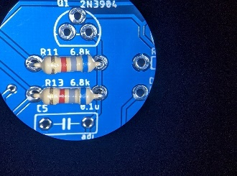 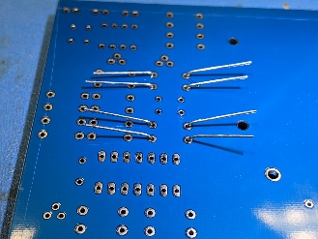

* **Solder components:** Apply the clean soldering tip to the junction of the component lead and the PCB. Feed in a bit of solder on the iron to make a liquid ball of hot solder. Wait 1-2 second for this ball to heat the lead and the PCB. Then feed in about an 1/8” – ¼” of solder. After removing the solder, keep heating the joint for an additional 1-2 seconds. This will encourage the solder to seep well into the hole, creating a solid electrical and mechanical connection between the component lead and the PCB. One final note, NEVER hold a component in place with your fingers.

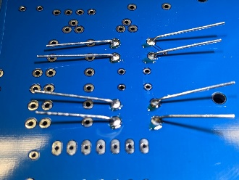

* **Trim leads:** This is the most dangerous step because when trimmed, the leads will fly away with surprising speed, creating a hazard to anyone nearby who is not wearing eye protection. Eye protection is mandatory while soldering, either safety glasses or eyeglasses. Prescription glasses are fine as we in a low-kinetic energy environment,

